December 31st, 2006
Hi
Last Monday, Christmas day, I slept in for an hour but then worked the rest of the day. Not much else to do!
On Tuesday, there was a big earthquake off Taiwan, which affected HK with a slight tremor. At 8:37 pm, while on the sofa watching TV, I felt my legs quivering slightly. I thought, ‘Oh Oh’, either something is going wrong with me or else this is an earthquake. Of course, it was an earthquake, but so slight that if I had not been lying down I would not have felt it. However, in some places it might have been stronger, as the next day’s TV news showed residents on the street having evacuated their buildings.
Of course, as you probably know, the earthquake has seriously affected Internet communications. Six of the seven cables that serve HK, Taiwan and beyond have been damaged. I noticed this on Wednesday when almost nothing would open. It turns out that it could take up to a month to repair the damaged cables. In the meantime, the cable companies are re-directing traffic using other cables (I guess that means via Singapore and westwards rather than across the Pacific). Things are opening better now, so I guess this letter will get through to you.

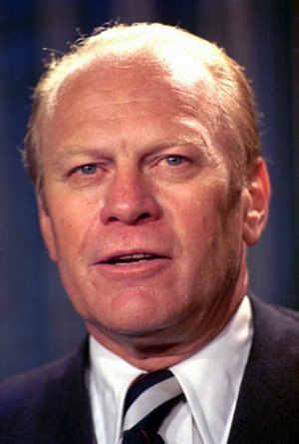
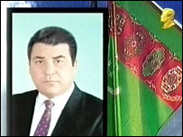
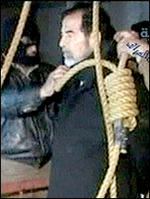
Well, it has certainly been a time for the death of presidents and former presidents. First, on December 21st, the authoritarian president of Turkmenistan, Saparmurat Niyazov, who ruled the Central Asian country for 21 years, died. Then, last week, the former US president, Gerald Ford, died, aged 93. He is mainly remembered for having to take over the presidency in 1974 when Nixon resigned. I will remember him for something else, however. While I was in Los Angeles with Gavin, there was a big charity function to which he was invited. It turned out he demanded huge fees for attending, both for him and for the Betty Ford foundation. A few other celebrities who attended also demanded fees though many didn’t, such as Bill and Hillary Clinton. Of course, the biggest news I suppose of a former president to die was the execution of Saddam Hussein. He was hanged at 6 am yesterday, Baghdad time. (Photo courtesy of the Boston Herald.)
The run yesterday started badly and I thought of giving up – run a few metres then have to stop and walk. However, I kept going and it was better when my body warmed up. Near the end, I came across an orienteering competition, with people ploughing through trees and undergrowth and clambering over rocks in a stream. Do you know what orienteering is? It is a combination of cross-country running and map reading. Competitors are given a map with several checkpoints marked on it and have to get from one to the next any way they like. This race featured on the evening news but only because a Japanese woman fell down a ravine and had to be rescued.
On returning from the run, spent a lot of time in bed. Apart from 2 hours for dinner and news, was in bed for another 17 hours.
On Friday, in the gym, I did a few minutes skipping. But just a few minutes and only 1 minute at a time followed by ½-minute rests. Tough! It’s been a long tie since I have done any skipping. However, I may continue to do a little now.
Have also slightly injured my lower back, but not through exercise. Last Monday, while walking to the gym, I felt a slight twitch in my lower back and immediately suspected what had happened. Still did exercise every day though. But occasionally in the evenings, my back would remind me that it is injured.
That’s about it for now.

Cheers

